**GIT Assignment – 4**

**● Put master.txt on master branch, stage and commit**

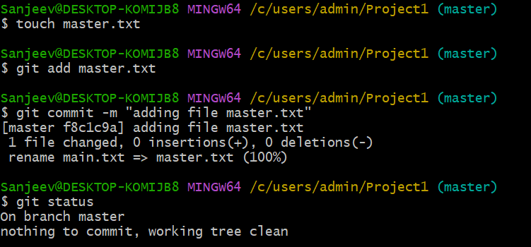

**● Create 3 branches: public1, public2 and private**

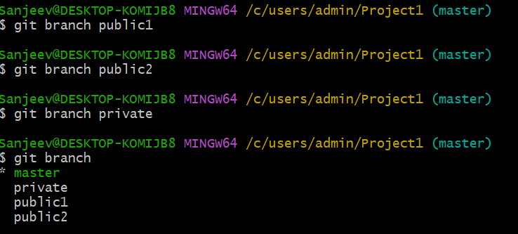

**● Put public1.txt on public 1 branch, stage and commit**

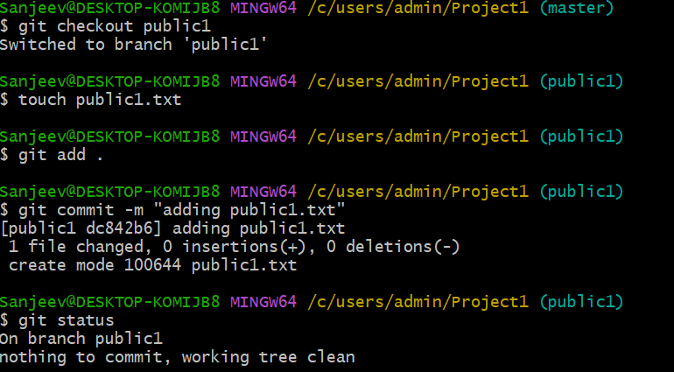

**● Merge public 1 on master branch**

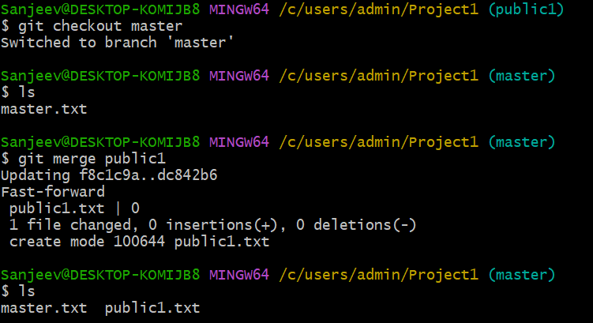

**● Merge public 2 on master branch**



**● Edit master.txt on private branch, stage and commit**

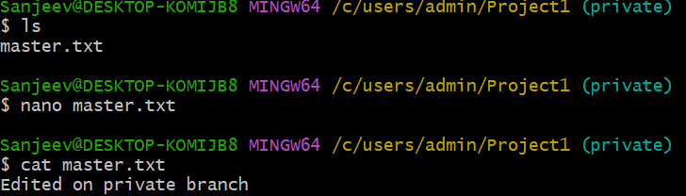

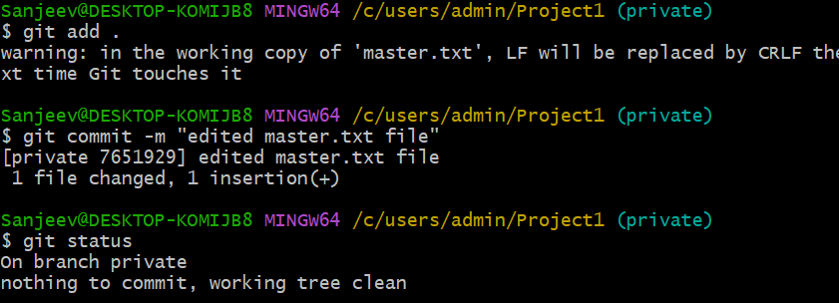

**● Now update branch public 1 and public 2 with new master code in private**

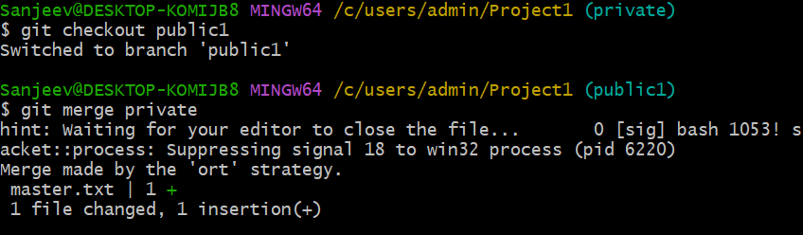

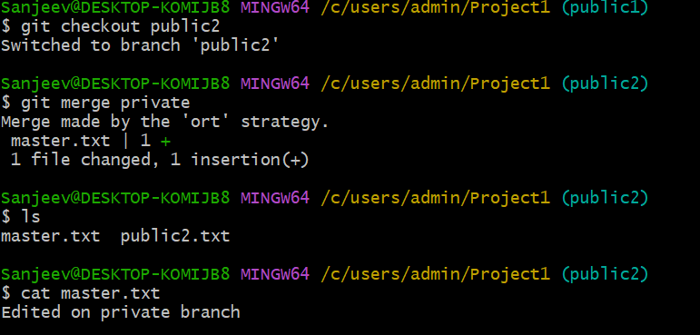

**● Also update new master code on master**

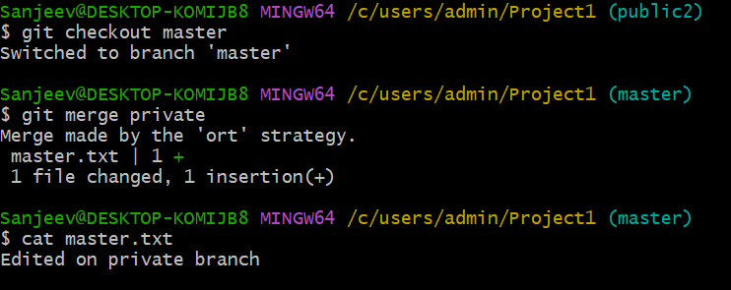

**● Finally update all the code on the private branch**

